Dear Colleagues,
In an effort to continue to use Telehealth as a tool after the state of emergency has ended, it is important to begin to develop a plan for how your practice can effectively and compliantly continue to practice telemedicine.

Please click here to access information from the Federal State Medical Boards (FSMB) regarding U.S. States and Territories Modifying Requirements for Telehealth in Response to COVID-19 (Out-of-state physicians; pre existing provider-patient relationships; audio-only requirements; etc.) We urge each provider to be licensed in the state where the patient is located, unless there are provisions in place otherwise due to the pandemic.

We recommend you analyze patient data to determine where your patients are living to best determine the states that each provider would benefit in obtaining a state license within. This communication includes a few out of state licensure options:
● Interstate Medical Licensure Compact
● New Hampshire
● Maine
● Florida

Please do not hesitate to reach out to Alycia Messelaar, Alycia.Messelaar@lahey.org or 978-236-1784 with any questions or if you would like assistance with researching how to obtain a license in a state not listed in this communication.

Thank you,
Alycia Messelaar
Northeast PHO
Manager, Provider and Payor Relations

Interstate Medical Licensure Compact

Please go to http://www.imlcc.org/ for directions.

The Interstate Medical Licensure Compact offers a streamlined licensing process for qualified physicians who wish to practice in multiple states– eliminating the need to manage multiple applications.

If eligible, you can qualify to practice medicine across state lines within the Compact if you meet the Compact’s agreed-upon eligibility requirements. You may apply through the Compact for licensure in multiple states, receiving separate licenses from each state in which you intend to practice. The states chosen must be participants in the Compact. Please see below for U.S. state Compact Licensure participation.

These licenses are still issued by the individual states – but because the application for licensure in these states is routed through the Compact, the overall process is obtained faster and with fewer burdens. Approximately 80% of U.S. physicians meet the criteria for licensure through the Compact. See if you qualify by clicking here.

The Compact currently includes 29 states, the District of Columbia and the Territory of Guam. In these jurisdictions, physicians are licensed by 43 different medical and osteopathic boards.

Physicians apply through the Compact to receive a Letter of Qualification from a State of Principal License (SPL). Physicians cannot obtain licenses through the compact unless they have an SPL and are issued a Letter of Qualification. In order to participate in the Compact, states must pass legislation authorizing it.
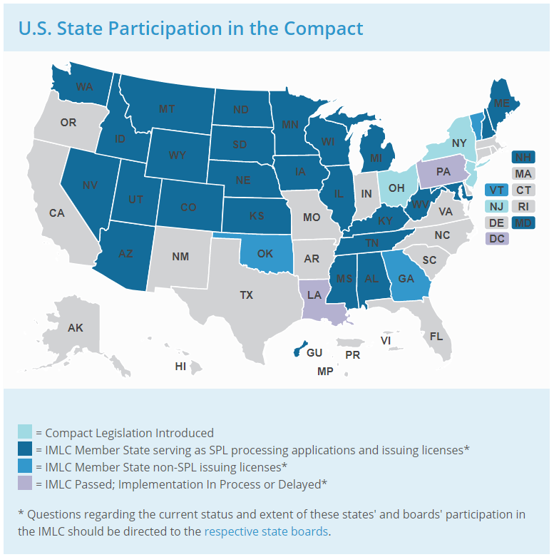

New Hampshire (MD/DO)
(BOARD WEBSITE)

Timeframe 10-16 weeks
Board Meeting Yes
Fingerprints Yes
FCVS Yes
Postgrad Training 2 years
Controlled Substance Regulation No
License application: https://www.oplc.nh.gov/medicine/documents/physician-instructions-addendum-affidavit.pdf

NH Specific license emergency orders:

● https://www.governor.nh.gov/sites/g/files/ehbemt336/files/documents/emergency-order-29-h.pdf

● https://www.governor.nh.gov/sites/g/files/ehbemt336/files/2020-05/emergency-order-46.pdf

Maine (MD)
(BOARD WEBSITE)

Timeframe 12 Weeks
Board Meeting Yes
Fingerprints No
FCVS Yes
Postgrad Training 2 Years
Controlled Substance Regulation No
Notes Physicians in Maine must complete all three steps of the USMLE in seven years with no more than three attempts on step three. Applicants exceeding three attempts on step three must submit a written request for a waiver. In order to qualify, no more than three medical malpractice claims shall have been filed against the applicant in a 10-year period, nor shall there have been any one medical malpractice settlement resulting in an amount greater than $300,000. Providers with any disciplinary actions and/or criminal background are disqualified from emergency licenses.
License application: http://www.imlcc.org/

Maine (DO)
(BOARD WEBSITE)

Timeframe 8-12 weeks
Board Meeting No
Fingerprints No
FCVS No
Postgrad Training 1 year
Controlled Substance Regulation No
License application: http://www.imlcc.org/

Florida (MD)
(BOARD WEBSITE)

Timeframe 12-16 weeks
Board Meeting No
Fingerprints Yes
FCVS No
Postgrad Training 1 year; 2 years IMG
Controlled Substance Regulation No
Notes Florida has no limit on USMLE times or attempts. Physicians must submit proof of 24 months of practice over the past four years preceding the date of the application.
License application: http://flhealthsource.gov/mqa-services

Florida (DO)
(BOARD WEBSITE)

Timeframe 8-12 weeks
Board Meeting No
Fingerprints Yes
FCVS No
Postgrad Training 1 year
Controlled Substance Regulation No
License application: http://flhealthsource.gov/mqa-services

Florida Telehealth provider registration:
https://flboardofmedicine.gov/licensing/out-of-state-telehealth-provider-registration/

